**Batch: C3-1 Roll No.: 16010122221**

**Experiment / assignment / tutorial No.**

**Grade: AA / AB / BB / BC / CC / CD /DD**

**Signature of the Staff In-charge with date**

|  |
| --- |
| **TITLE: Decision Making Statements** |

**AIM:** 1) Write a program to count the number of prime numbers and composite numbers entered by the user.

2) Write a program to check whether a given number is Armstrong or not.

**______________________________________________________________________**

**Expected OUTCOME of Experiment:** Use different Decision Making statements in Python.

**______________________________________________________________________**

**Resource Needed: Python IDE**

**______________________________________________________________________**

**Theory:**

**Decision Control Statements**

**1) Selection/Conditional branching statements**

a) if statement

b) if-else statement

c) if-elif-else statement

**2)Basic loop Structures/Iterative statement**

a) while loop

b) for loop

**If statement:**

In Python **if** statement is used for decision-making operations. It contains a body of code which runs only when the condition given in the **if** statement is true.

Syntax:

if condition:

statement(s)

If flowchart:  
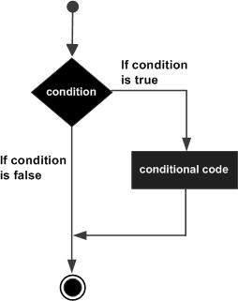

**If-else Statement:**

An **else** statement can be combined with an**if** statement. An **else** statement contains the block of code that executes if the conditional expression in the **if** statement resolves to 0 or a FALSE value.

The **else** statement is an optional statement and there could be at most only one **else**statement following **if**.

### Syntax:

if expression:

statement(s)

else:

statement(s)

If-else flowchart:

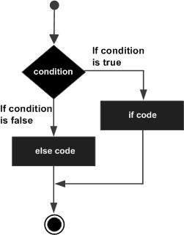

## If-elif-else Statement:

The **elif** statement allows you to check multiple expressions for TRUE and execute a block of code as soon as one of the conditions evaluates to TRUE.

Similar to the else, the **elif** statement is optional. However, unlike **else**, for which there can be at most one statement, there can be an arbitrary number of **elif** statements following an **if.**

Syntax:

if expression1:

statement(s)

elif expression2:

statement(s)

elif expression3:

statement(s)

else:

statement(s)

**While loop:**

A **while** loop statement in Python programming language repeatedly executes a target statement as long as a given condition is true.

Syntax:

while expression:

statement(s)

While loop flowchart:

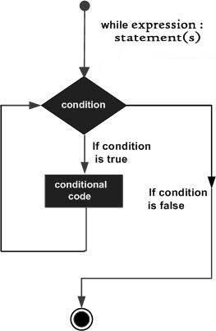

**For Loop:**

The [**for**](https://docs.python.org/3/reference/compound_stmts.html#for)statement in Python differs a bit from what you may be used to in C. Rather than giving the user the ability to define both the iteration step and halting condition (as C), Python’s **for**statement iterates over the items of any sequence (a list or a string), in the order that they appear in the sequence.

Syntax:

for iterating_var in sequence:

statements(s)

For loop flowchart:

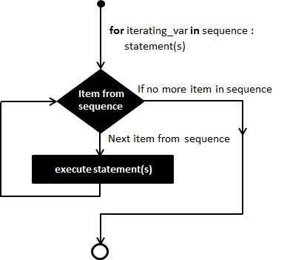

**Problem Definition:**

1)Write a program to read the numbers until -1 is encountered. Also, count the number of prime numbers and composite numbers entered by the user

2) Write a program to check whether a number is Armstrong or not.

## (Armstrong number is a number that is equal to the sum of cubes of its digits for example: 153 = 1^3 + 5^3 + 3^3.)

**Books/ Journals/ Websites referred:**

1. Reema Thareja, *Python Programming: Using Problem Solving Approach*, Oxford University Press, First Edition 2017, India
2. Sheetal Taneja and Naveen Kumar, *Python Programming: A modular Approach*, Pearson India, Second Edition 2018,India
3. https://docs.python.org/3/tutorial/controlflow.html#for-statements

**Implementation details:**

1.

n=int(input("Enter Integer "))

p=0

c=0

while(n!=-1):

   flag=True

   if(n<2):

      pass

   else:

         for i in range (2,n) :

             if(n%i==0):

                flag=False

                break;

         if(flag==False):

           c=c+1

         else:

           p=p+1

   print("enter -1 to exit")

   n=int(input("enter number :"))

print("number of prime number",p)

print("number of composite numbers",c)

2.

n=int(input())

n1=n

k,sum=0,0

if(n<0):

    print("Invalid Input")

else:

    while(n!=0):

        k=n%10

        sum+=pow(k,3)

        n//=10

    if(n1==sum):

        print("The number is Armstrong")

    else:

        print("The number is NOT Armstrong")

**Output(s):**

1.

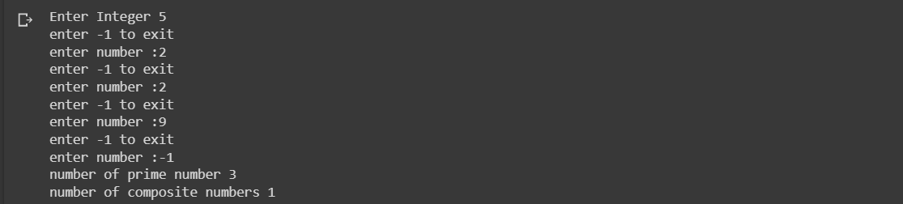

2.





**Conclusion:**

Used nested conditional statements to execute and carry out the give aim of the experiment. Also learnt to utilize multiple conditional statements to check for different possible outcomes.

**Post Lab Questions:**

1. When should we use nested if statements? Illustrate your answer with the help of an example.

We use nested conditional statements under various applications where in multiple checks are needed to carry out under a specific condition. For example a program which checks if the number entered is positive or negative and if it’s positive then check if its less than 10.

n=int(input("Enter a number: "))

*if* n<0:

print("The number is Negetive")

*else*:

*if* n<10:

print("The number is Postive and less than 10")

*else*:

print("The number is Positive")

1. Explain the utility of break and continue statements with the help of an example.

The **break** statement in python terminates and exits out the current loop and resumes the execution out of the loop statement. For example

1. *for* i *in* range(1,10):
2. *if* i % 5 == 0:
3. *break*
4. print(i)

Over here when i becomes 5 the break statement will be executed and the loop ends and so does the program. So it prints numbers from 1 to 4.

The **continue** statement in python returns the control to the next iteration of the loop. For example.

*for* i *in* range(1,10):

*if* i % 5 == 0:

*continue*

print(i)

Here the loops runs normally but when i becomes 5 the continue statements transfers directly to the next iteration without executing the rest of the loop. So it print 1 to 9 except the number 5.

3) Write a program that accepts a string from user and calculate the number of digits and letters in string.

n=input("Enter a string: ")

d,a,s=0,0,0

*for* i *in* n:

*if* i.isdigit():

d+=1

*elif* i.isalpha():

a+=1

*else*:

s+=1

print("The number of Digits:",d)

print("The number of Letters:",a)

print("The number of Special Characters:",s)

**Date: _____________ Signature of faculty in-charge**